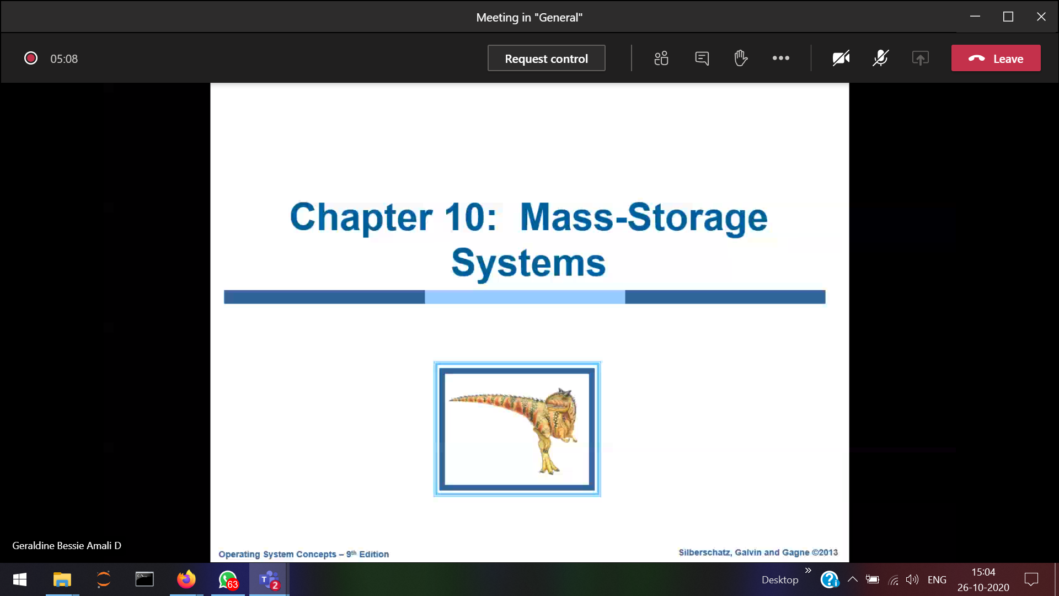

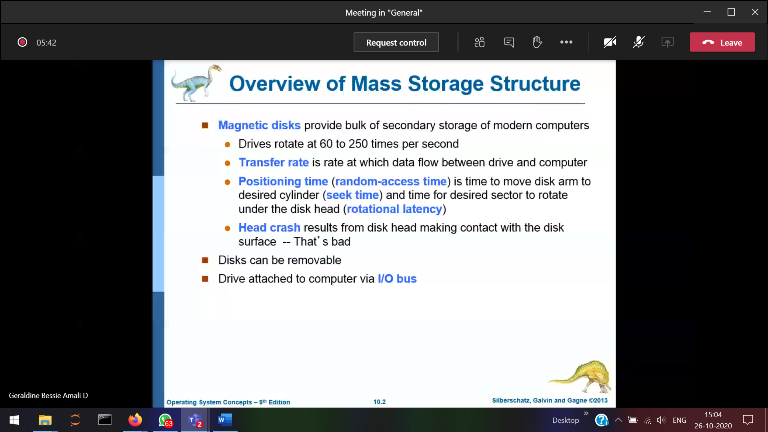

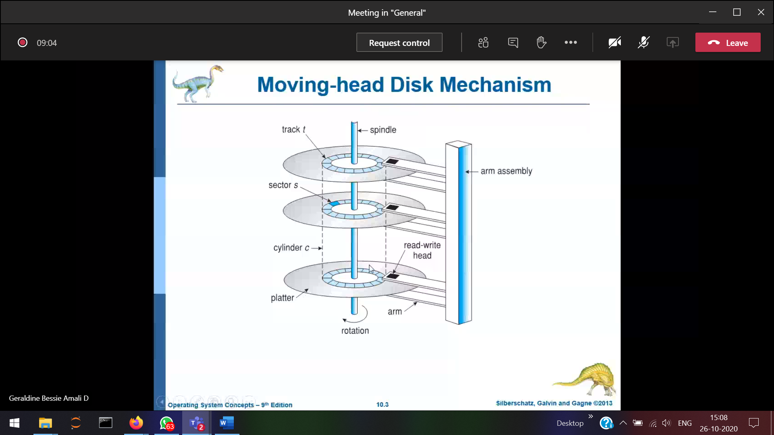

Whether the arm moves/cd rotates????

The data can be stored both on the top and bottom of the cd-like structure unlike the normal cd  
The spindle will enable the cd to rotate

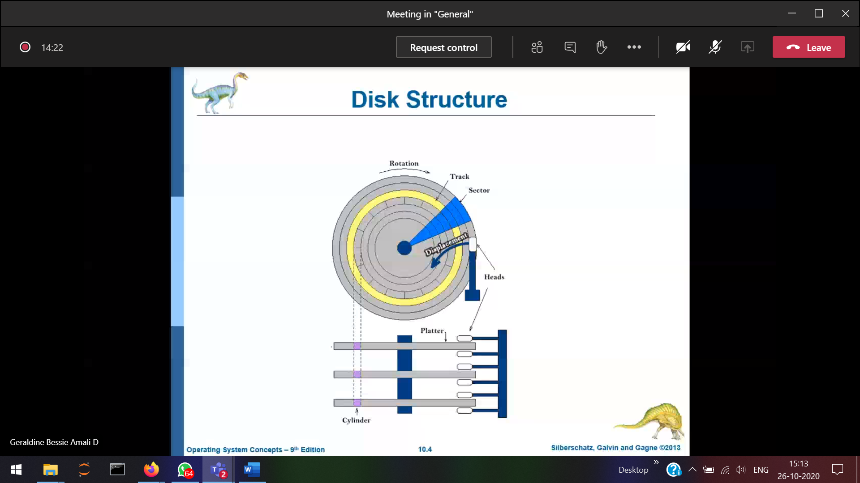

Data is stored in sectors

Tracks 🡪 sectors

Track 0 of all the platters will look as a cylinder from the upper view.

For every platter, there will be 2 read/write head.





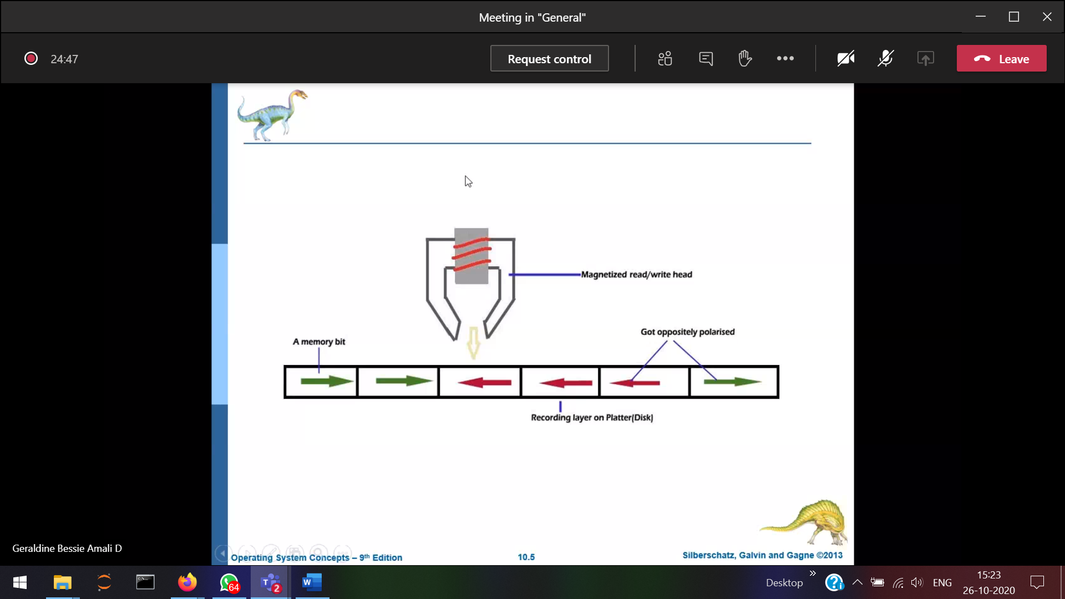



When the platter and the read write head joins 🡪 head crash.  
Opposite charges 🡪 1 (switch on) a small electrical signal will be generated.

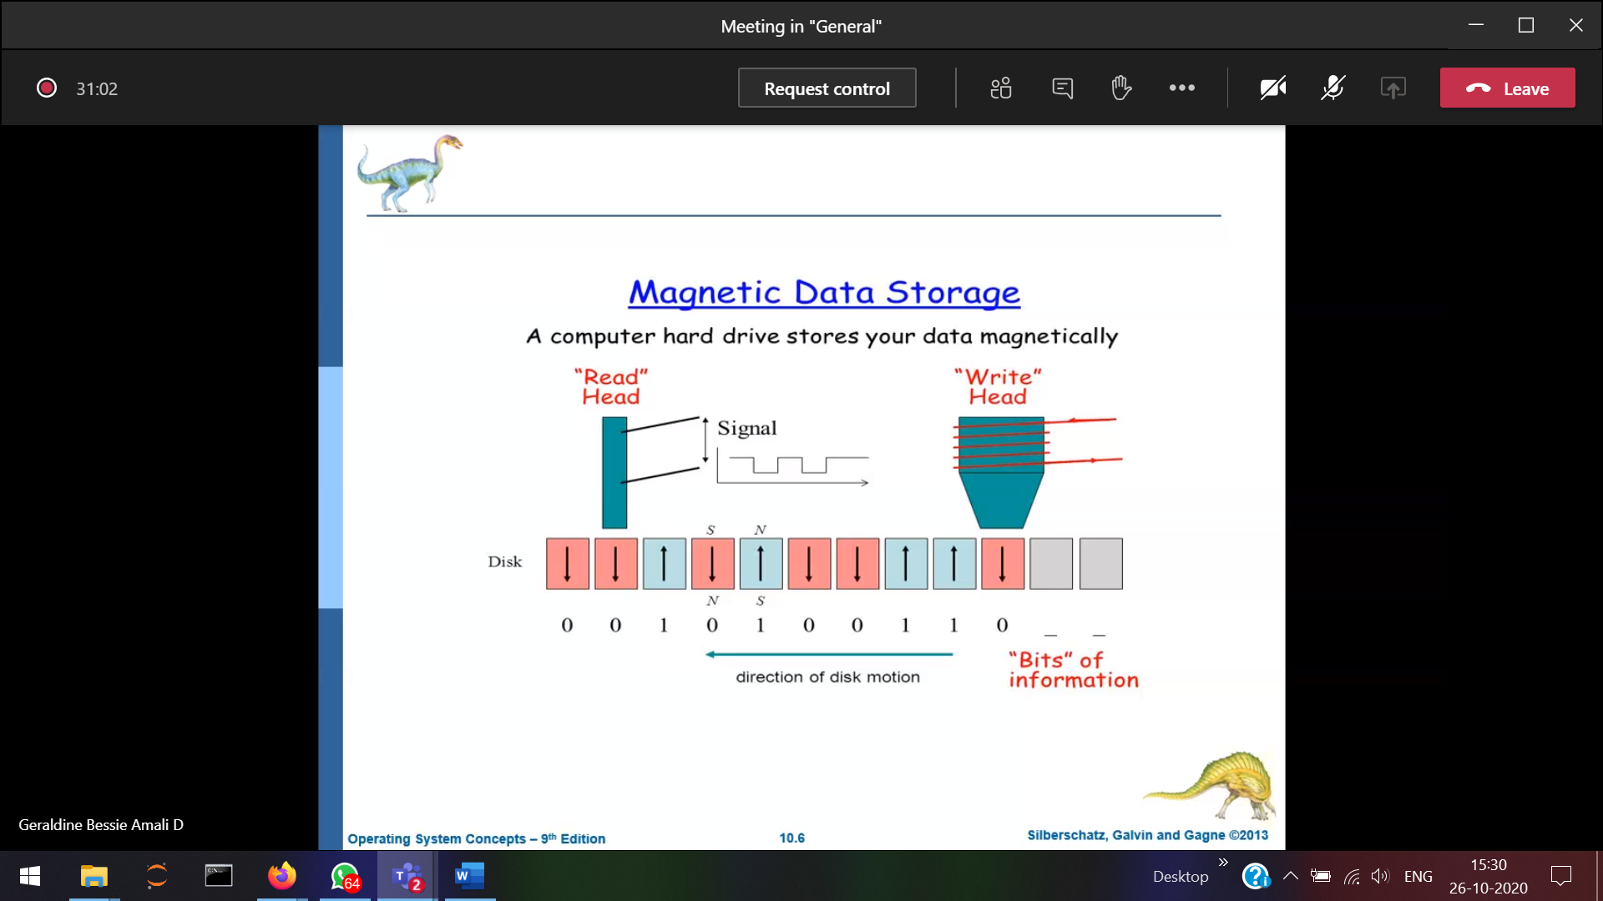

Platters(8), surface(2), tracks(256), Sectors(512), Data(512 KB)  
Disk size 🡪 platter*surface*tracks*sectors*data

Disk size 🡪 8*2*256*512*512KB(amount of data in each sector) 🡪 2^40 bytes which is equal to 1TB (2^40 bytes)



How many bits are required to represent the Disk size ??? 🡪 40bits



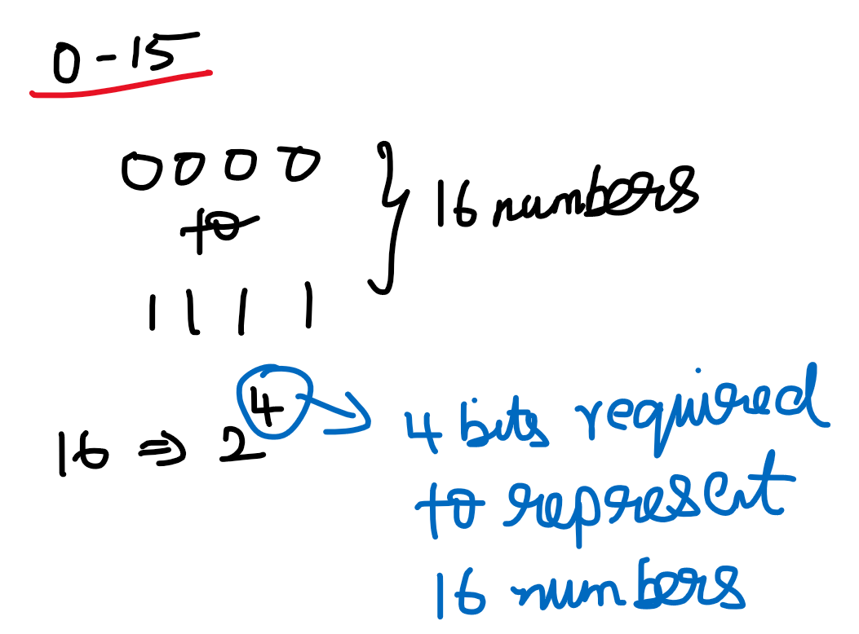

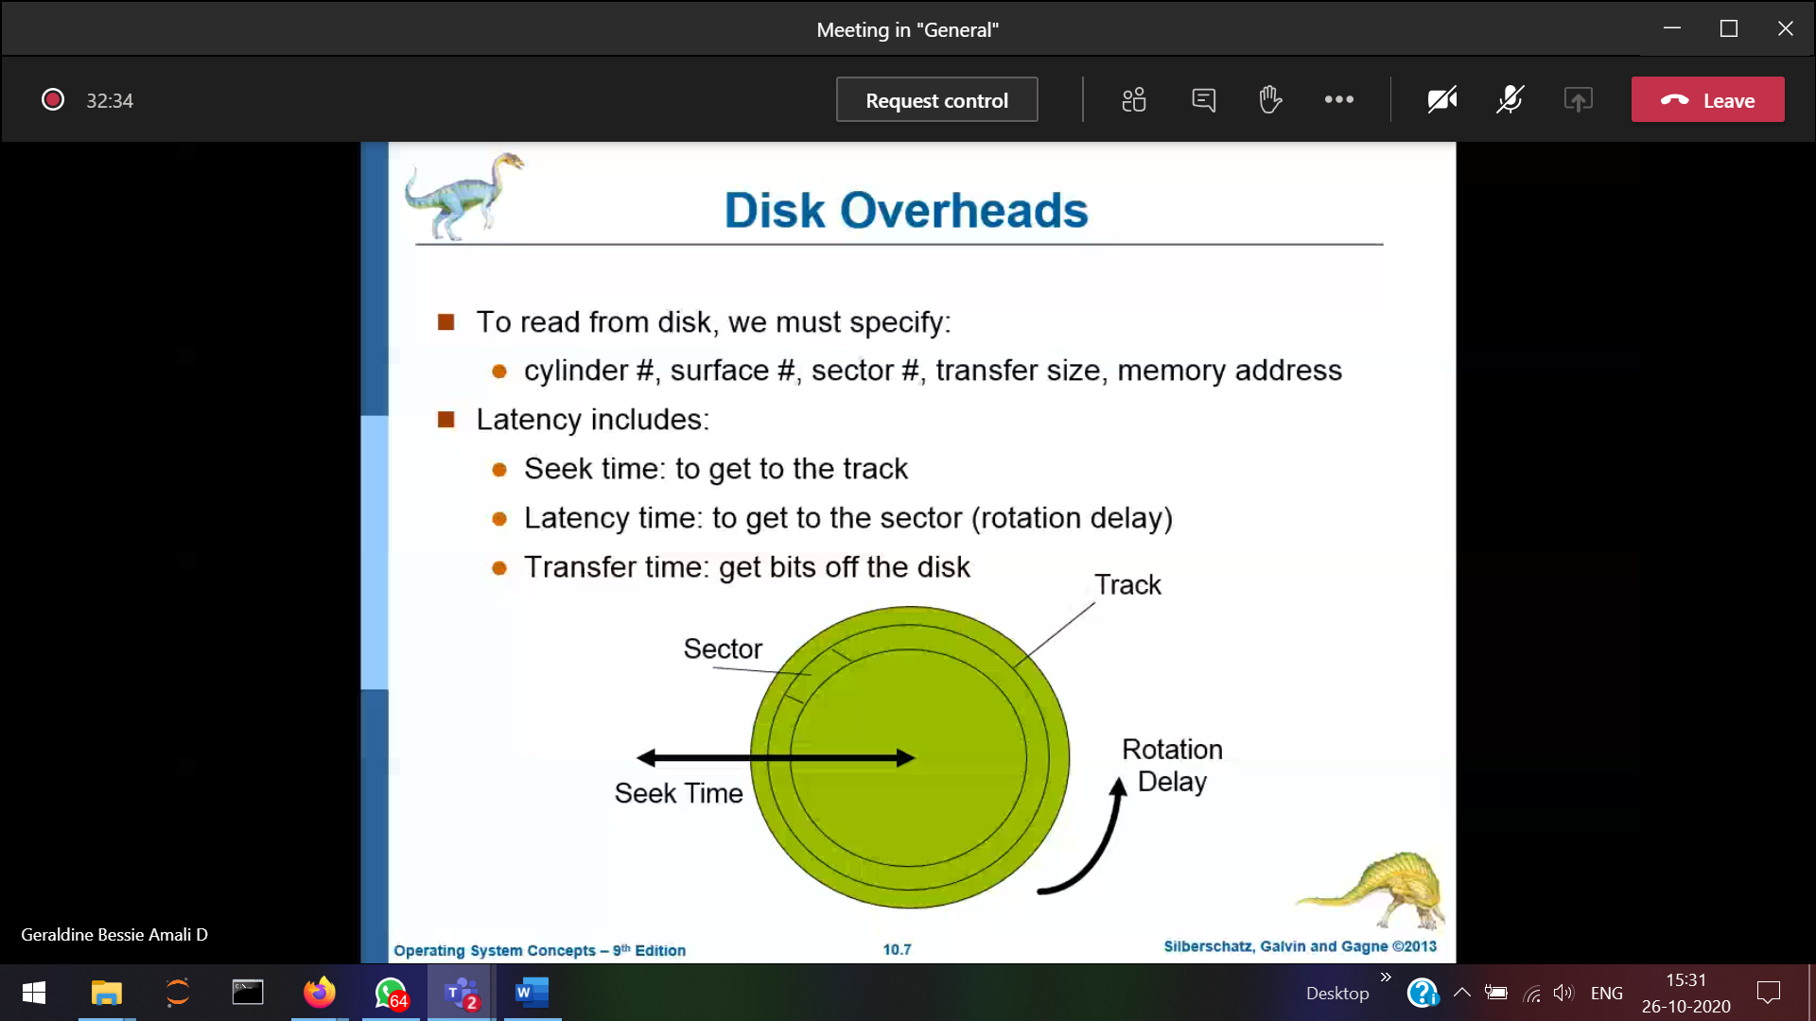

surface number 🡪 track number  
In 1 platter, how many tracks are present???

**How to reach the track ??  
Seek time** 🡪 time to Positioning at a exact cylinder under the read-write head.  
It is the time required by read/write head to move from one track to other.  
best case 🡪 the position where the read-write head stays, at that track if required data is present in one of the sector.  
worst case 🡪 the position where the read-write head stays, at that track if required data is not present in one of the sector, and has to traverse too far to reach the track, where the required data is present in one-of the sector.  
Latency time 🡪 time to get the sector under the read-write head.

**How to reach the sector ??**

**Rotational time** 🡪 Time taken for 1 full complete rotation

**Rotational Latency(average)** 🡪 Time taken to reach the required sector(half of rotation time)

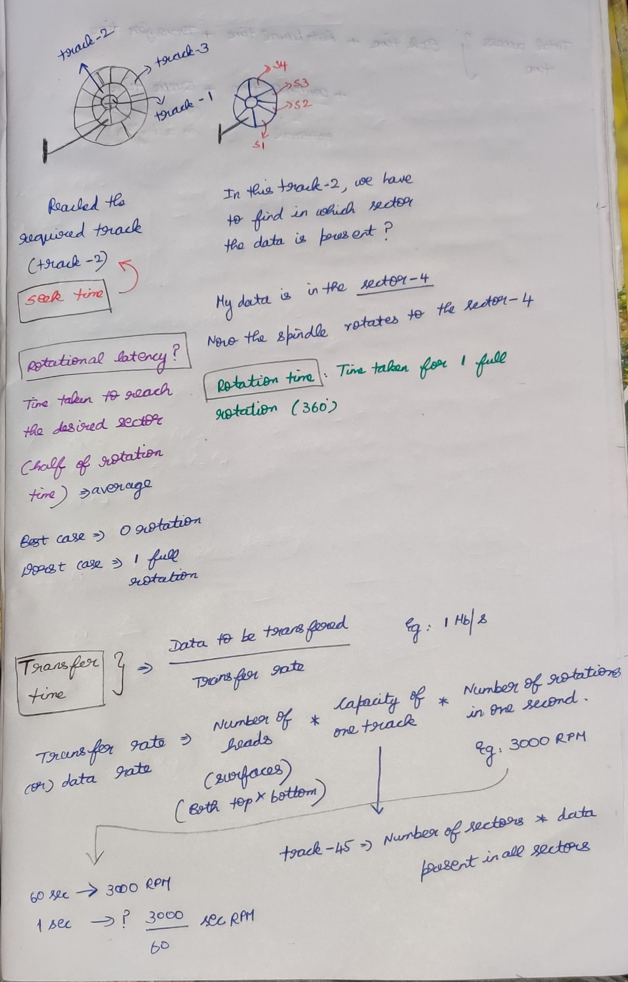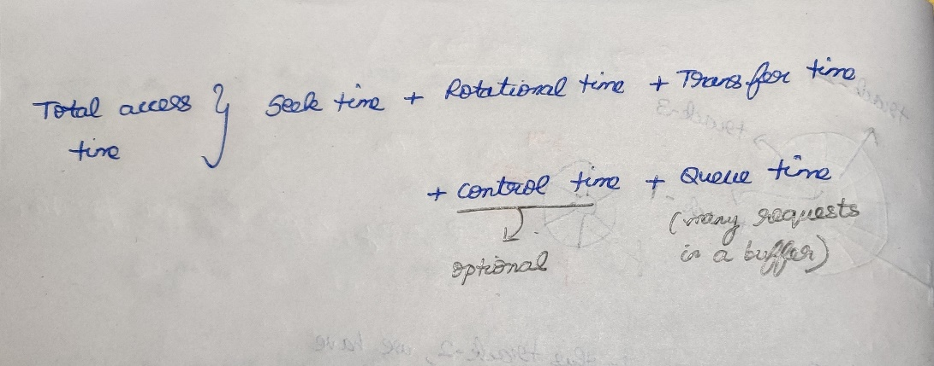

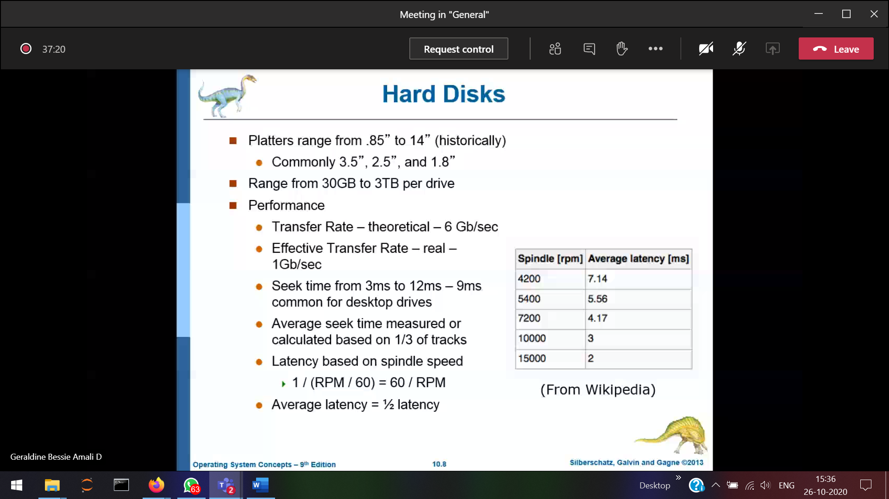

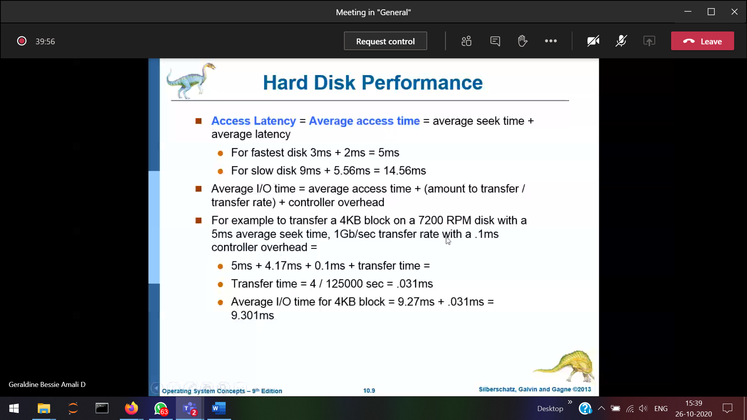

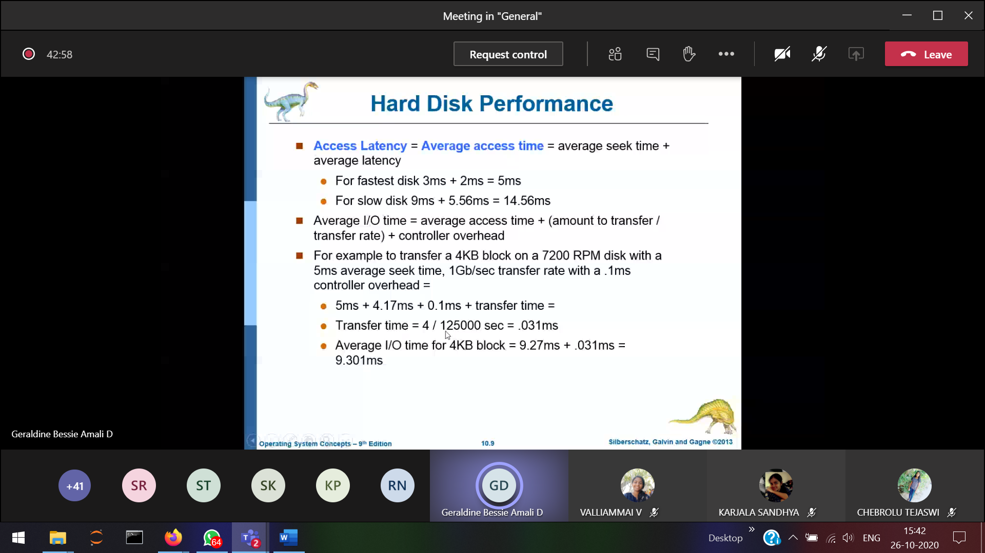

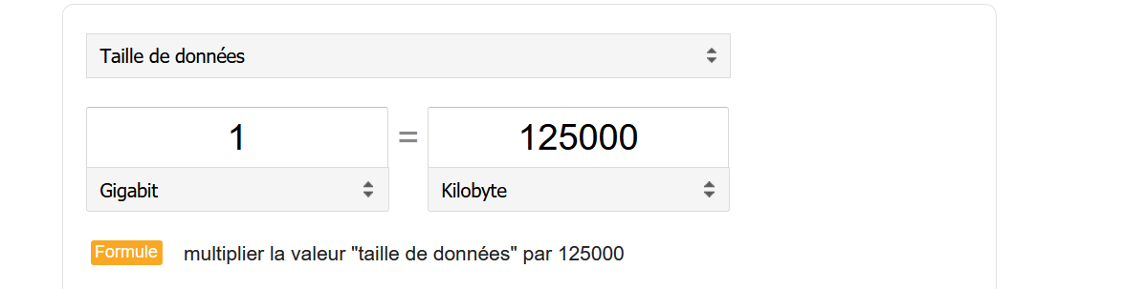

We can able to reduce only the seek time

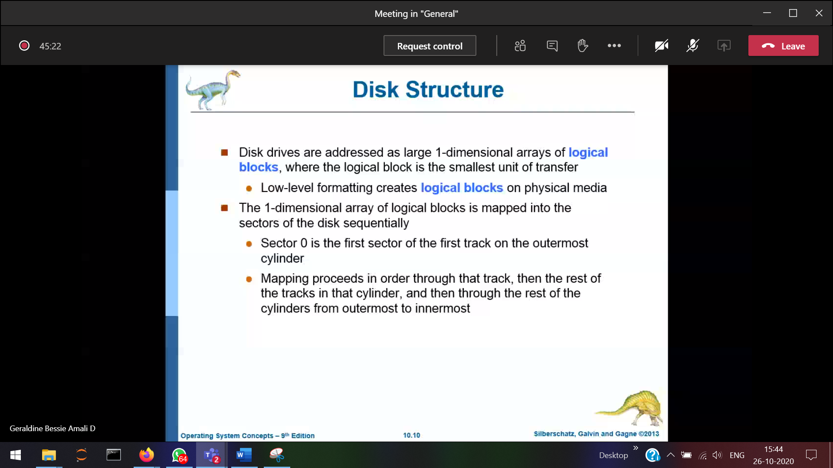

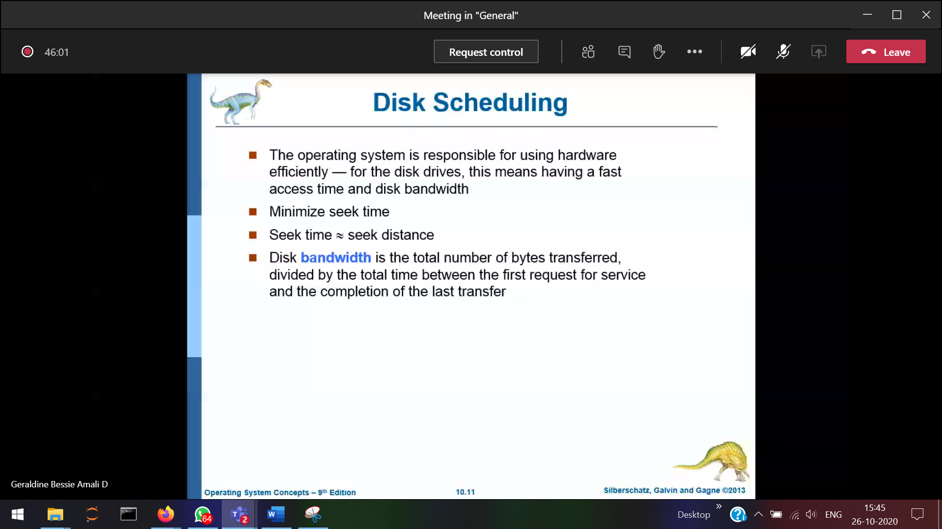

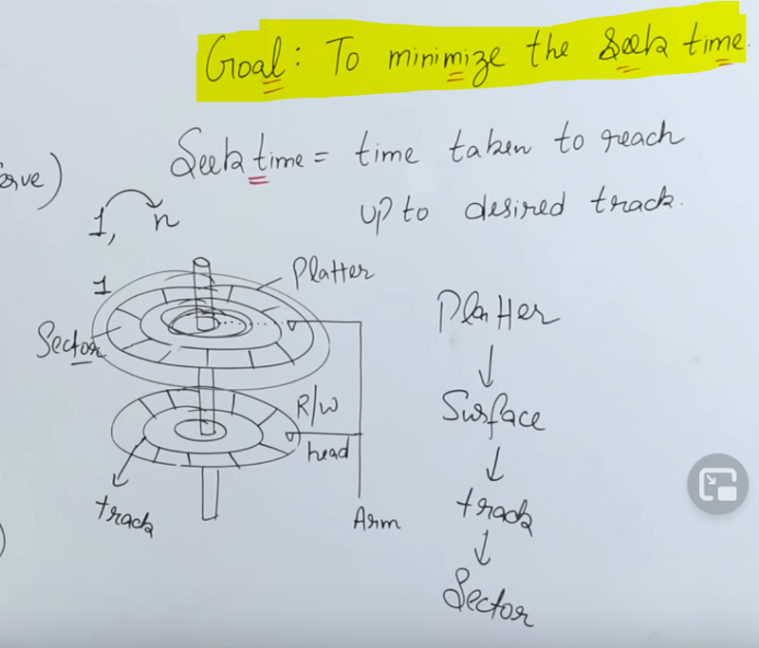

Scheduling Algorithms:

1. First Come First Serve (FCFS)
2. Short Seek Time First (SSTF)
3. SCAN
4. LOOK
5. CSCAN (Circular Scan)
6. CLOOK (Circular Look)

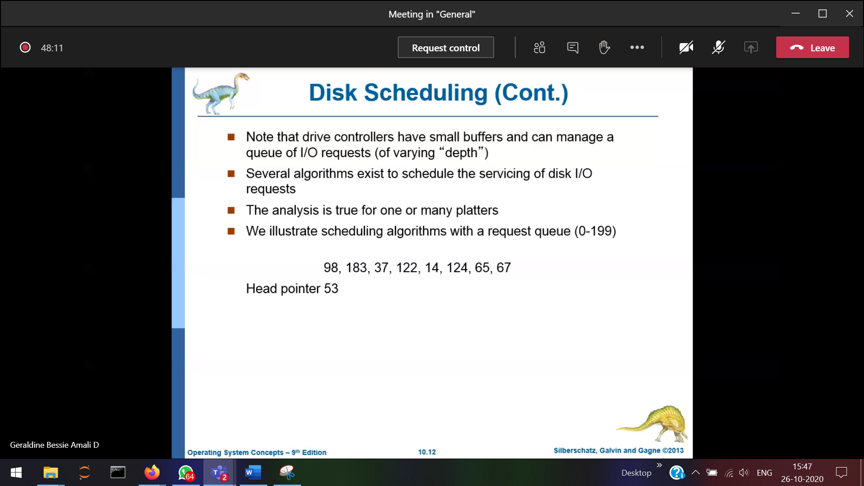

Performance metric for CPU scheduling algorithm : Waiting time, turn-around time

Performance metric for Disk scheduling algorithm : Seeking time  
lesser number of cylinder 🡪 then lesser seek time 🡪 then min I/O time.

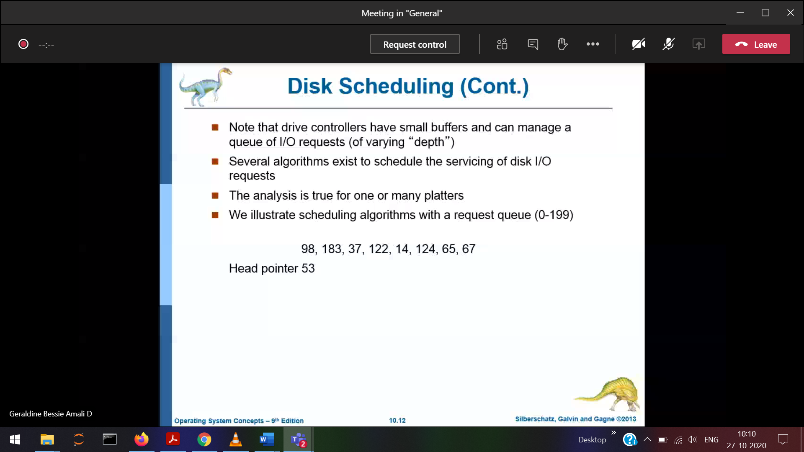

First Come First Serve Algorithm

Starvation 🡪 Will not occur

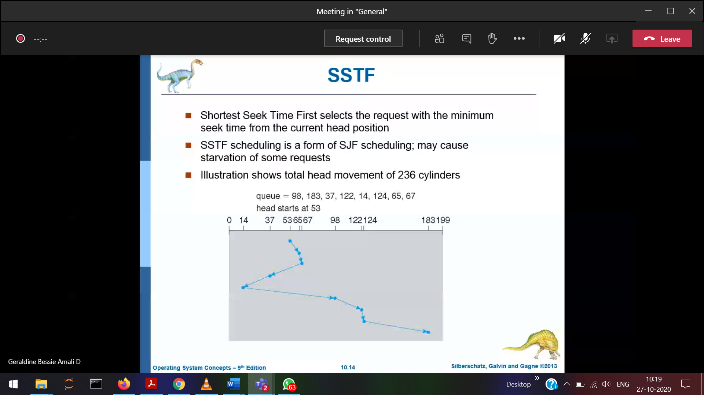

Shortest Seek Time First

Starvation 🡪 Will occur

